**Module 6**

* 1. **What are events in Google analytics?**

**ANSWER:**

**An event allows you to measure a distinct user interaction on a website or app. For example, loading a page, clicking a link, and completing a purchase are all interactions you can measure with events.**

* 1. **Connect your created website and blog to search console, analytics, and google tag manager and add your faculty as user with required permission in it.**

**ANSWER: Google search consol:**

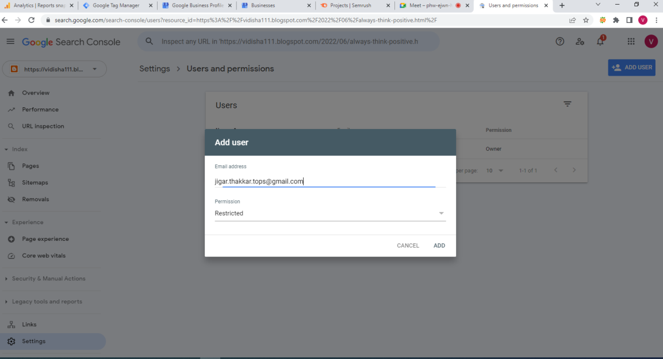

**Google tag manager:**

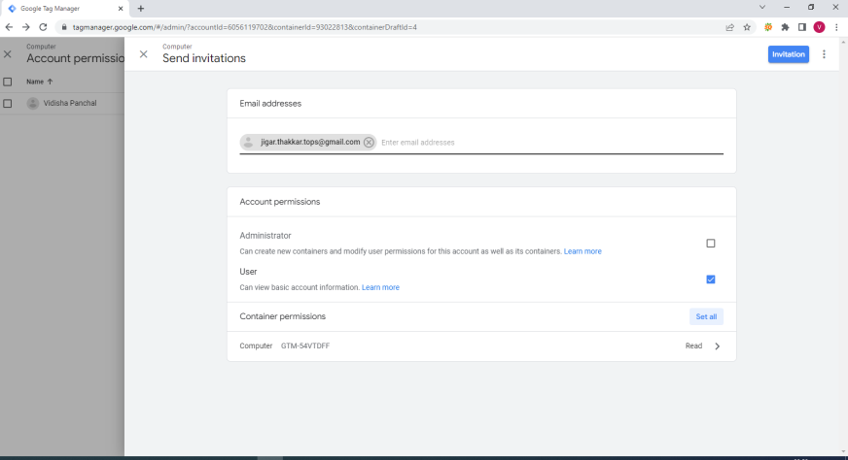

**Google analytics:**

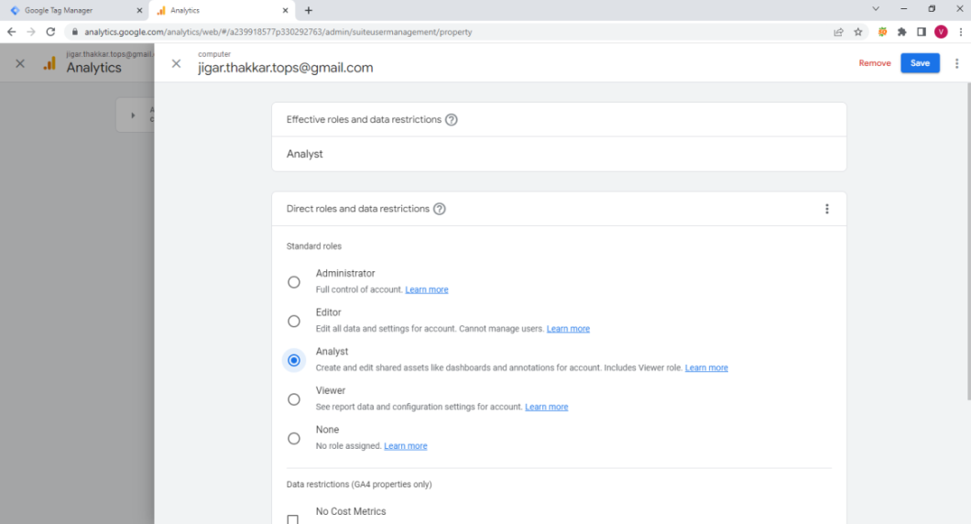

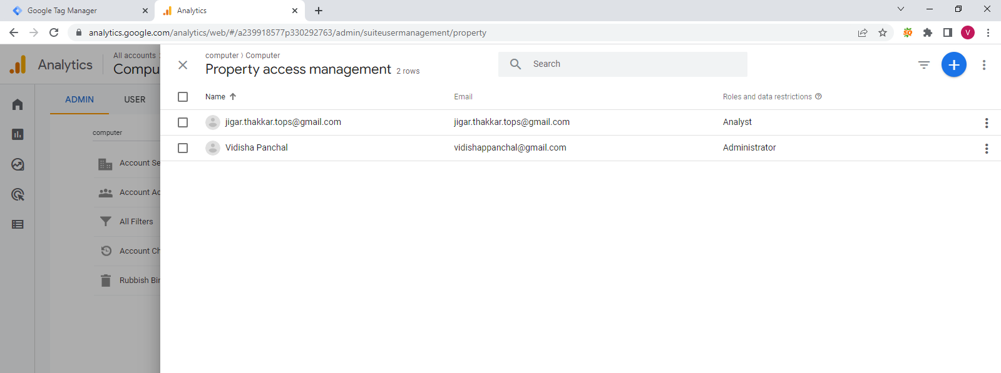

* 1. **Submit the sitemap and robot.txt file in the search console for your website.**

**ANSWER:**

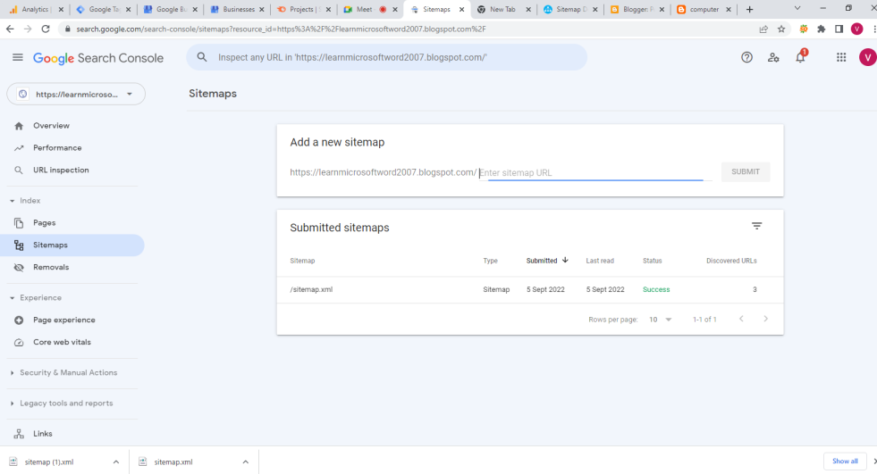

* 1. **Submit the user flow and traffic source reports for your website.**

**ANSWER:**

* 1. **Connect your blog to Google Analytics and study the different types of traffic on your site.**

**ANSWER:**

**Created blog and we create report in google analytics**

[**https://vidishaevent.blogspot.com/**](https://vidishaevent.blogspot.com/)

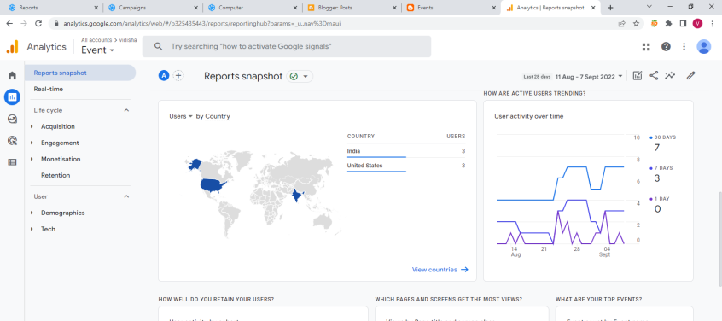

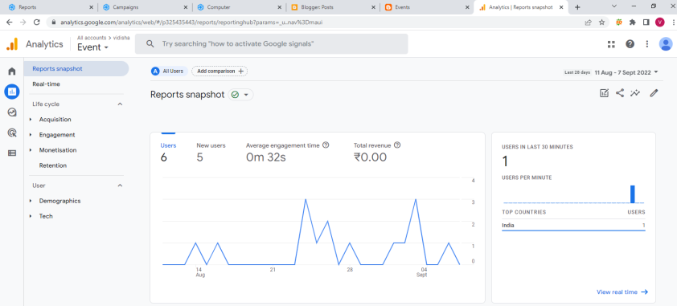

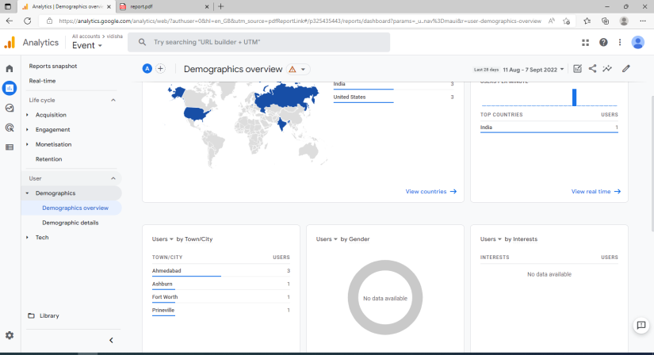

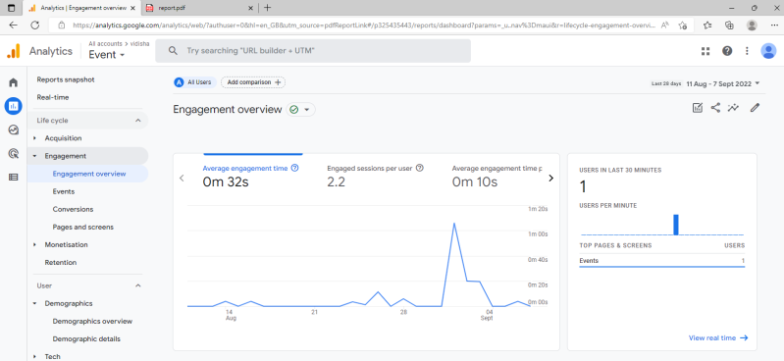

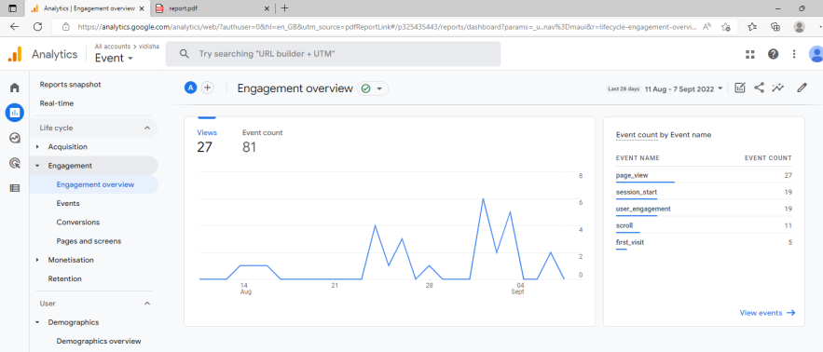

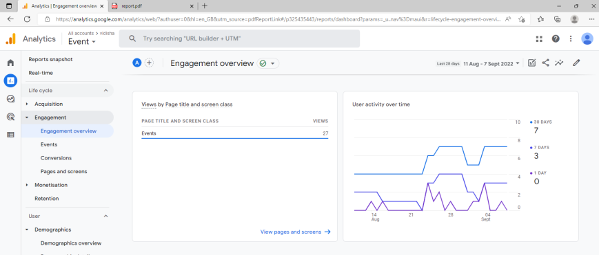

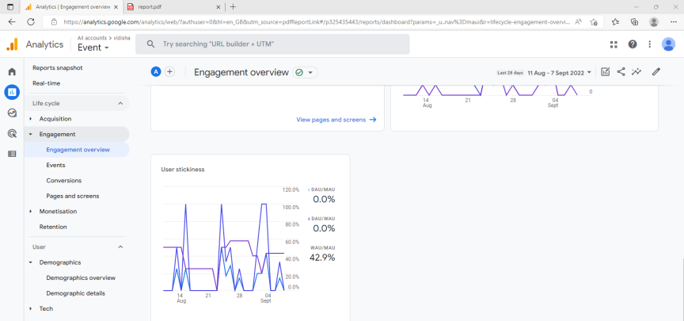

* 1. **Create a goal for your business and study reports whether it has been completed or not.**
  2. **Track the following interactions in Google tag manager for**

[**https://learnmicrosoftword2007.blogspot.com/**](https://learnmicrosoftword2007.blogspot.com/)

**ANSWER:**

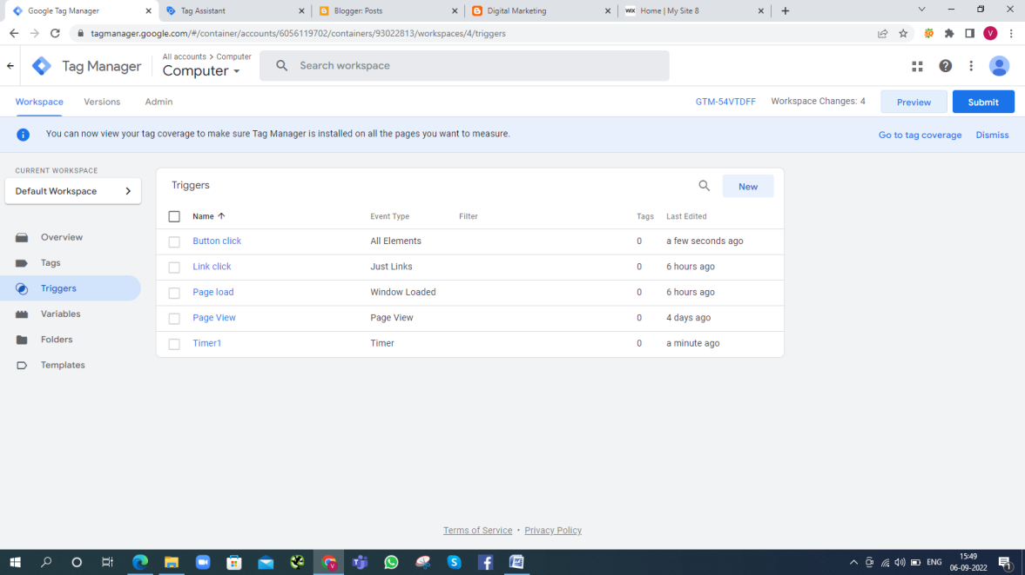

**-Link clicks**

**Link Clicks are the number of clicks on links to selected destinations or experiences, on or off Facebook-owned properties. (e.g. someone clicks Shop Now on your ad and goes to your website).**

**-Page load**

**Page load time is the average amount of time it takes for a page to show up on your screen. It's calculated from initiation (when you click on a page link or type in a Web address) to completion (when the page is fully loaded in the browser).**

**-Time (How long a visitor stayed on a particular page )**

**Users often leave Web pages in 10–20 seconds, but pages with a clear value proposition can hold people's attention for much longer. To gain several minutes of user attention, you must clearly communicate your value proposition within 10 seconds.**

**-Button click**

**Click is a term used to describe the action of pressing a mouse button (usually the left mouse button, if the mouse has two buttons) one or more times. Depending on the computer you are using or the software program you're in changes the action performed when clicking the mouse button.**